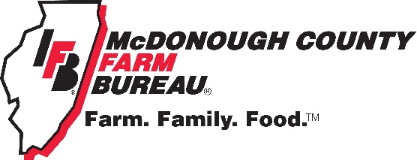
Local Discounts offered
to McDFB Members

Barsi Tax & Business Center - $30 off tax return preparation for new clients
CarX – 5% off Labor and parts
Farm King - $2.00 off regular price 20lb. LP tank fill
Gold Hills Golf Course - $22 for 18 holes w/cart
International Sandwich Shop – Free 16oz. fountain drink and 2 bags of chips when you purchase any 2 large subs or sandwiches
JB&D Siding and Window Company – 5% Windows, Siding, Roofing, Doors, and Sunrooms
Larry A’s Pizza - $2.00 off a large or family size pizza
Macomb Audiology and Hearing Aid Center – 10% off Hearing Aids
Mr. Sweeper - $1 off in stock sweeper bags
New Copperfield’s Book Service – 10% off books in-store and pre-paid special orders except consignments
Sherman Williams (Macomb) – Show your membership card for savings on your next project
Subway (West Side) – 10% off any purchase
The Enchanted Florist – 10% off wrapped flowers excluding holidays
The Scrapbook Nook – 10% off one time purchase
The Y – 15% discount on all single adult or family memberships
Tropical Isle Tanning - $10 off spray tan
West Central FS – Patronage refund when applicable
Western Illinois University – Buy 1 ticket get 1 free to any regular season home event. General admission only, excludes youth and senior tickets

*Must present your membership card to receive any discount

